**Step 1:** Make sure that both your room scan and video are anchored. Otherwise, they will be misaligned later.

**Step 2:** Export your video, making sure to include both the tracking data and the obj

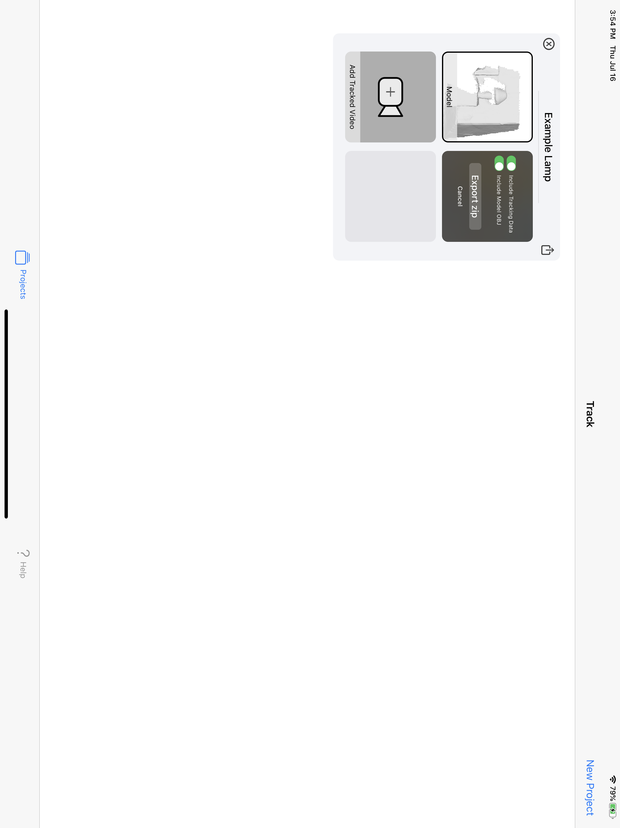

**Step 3:** Open the zip on your computer

**Step 4:** Create a new blender file and remove the default cube (right click it and press x), making sure to leave the default camera

**Step 5:** Import your room scan:

Go to File -> Import -> Wavefront (.obj)

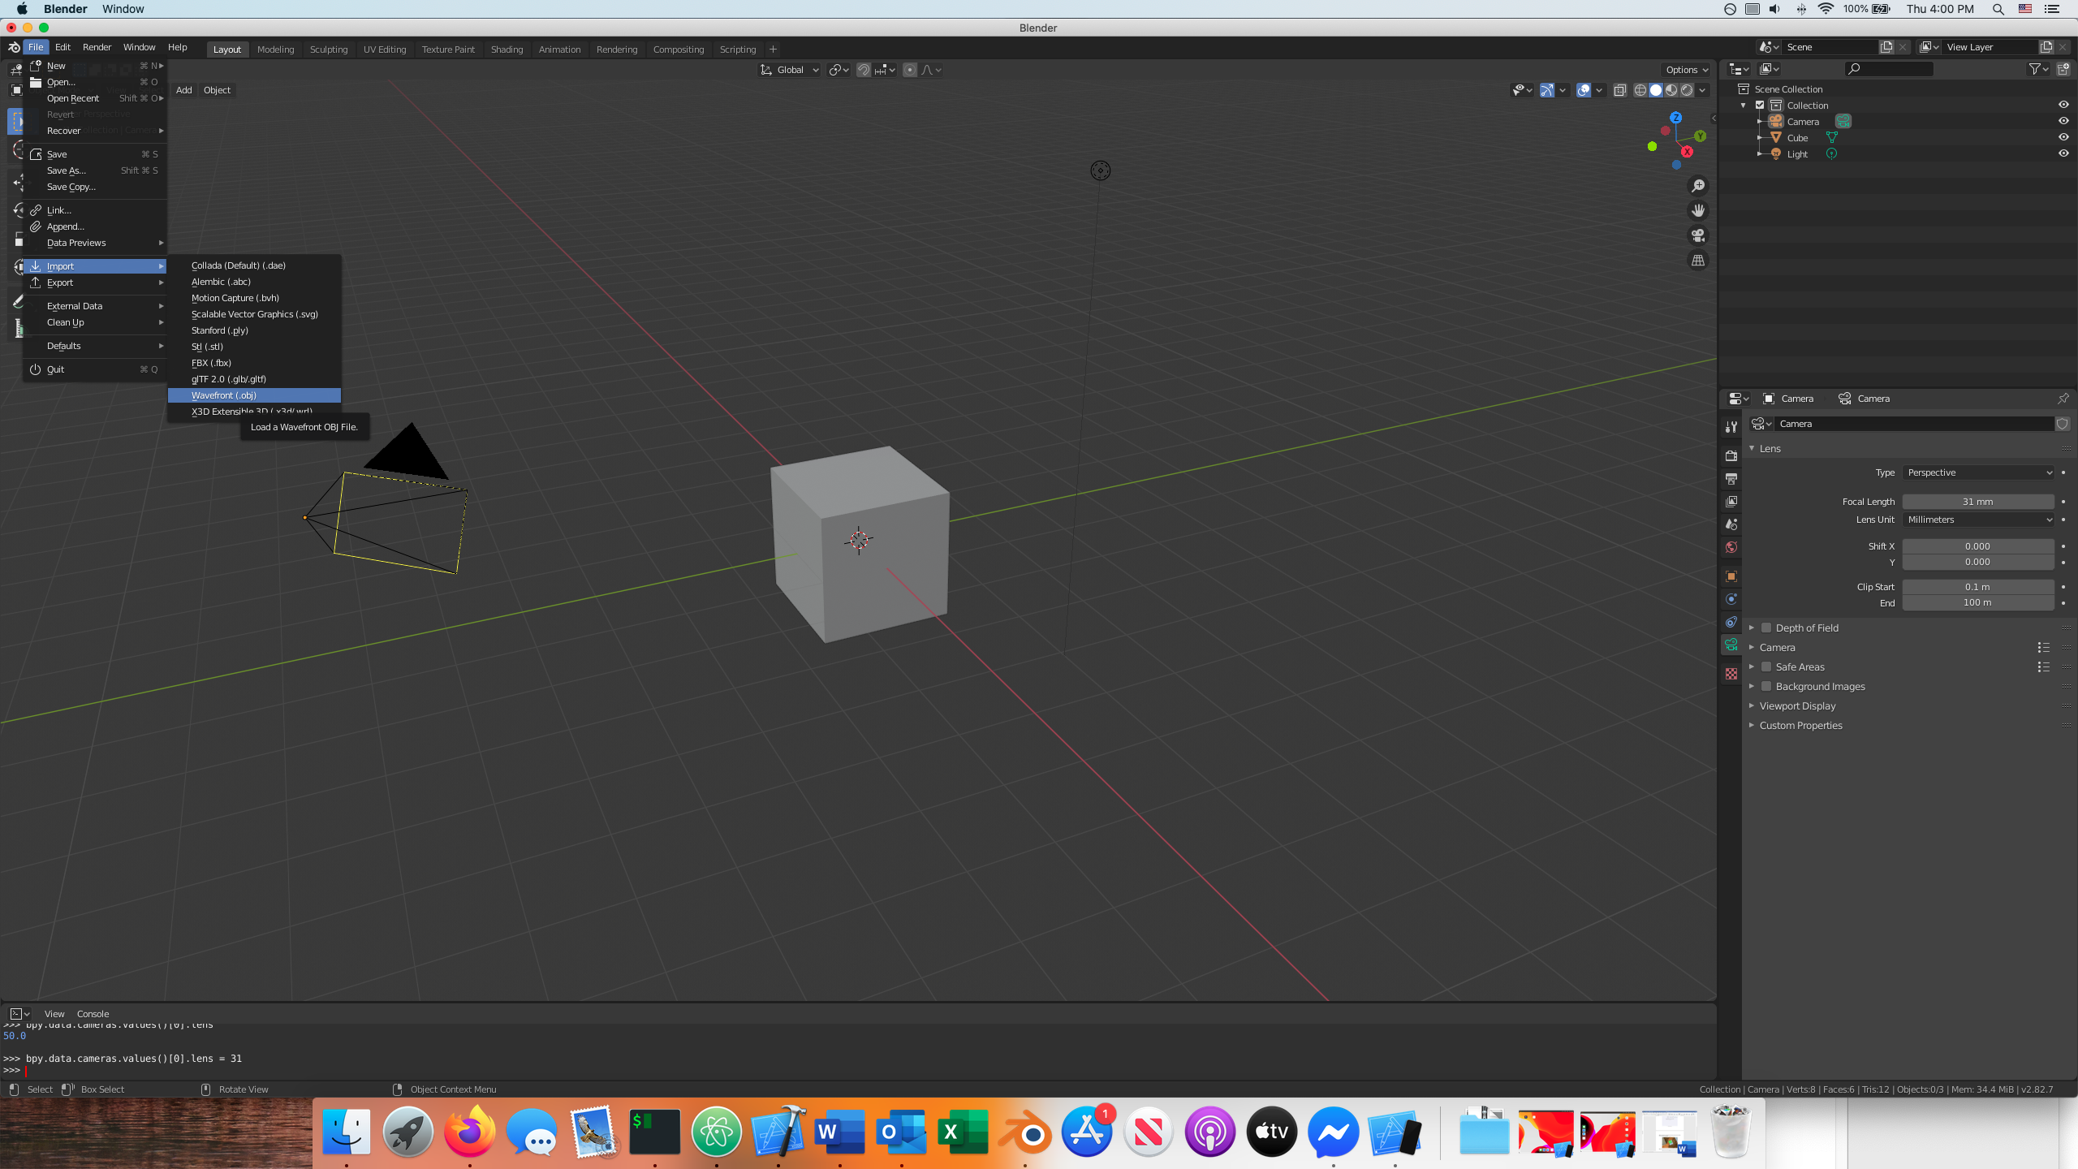

Select the model.obj file you exported, and change the setting to Forward:Y and Up: Z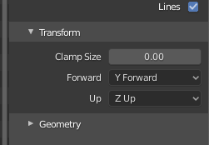

Click import OBJ.

**Step 6:** Adding the script:

Change the bottom window to “Python Console”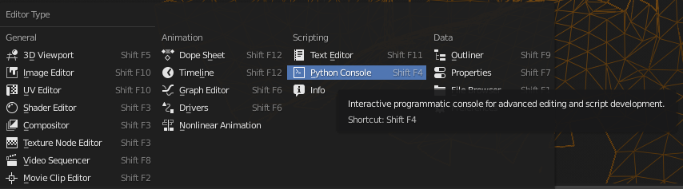

Enter: exec(open(“/A/B/videoXtrack_blender.py”).read()) , replacing “A/B/ videoXtrack_blender.py” with the path to the exported python script. Then press Enter on your keyboard. If successful, it should return “Successfully imported tracking data”.

Congrats, you have now imported your model and tracking data. Continue for previewing instructions.

**Step 7:** Let’s see our world from the perspective of the camera. In the viewer window, click View -> Cameras -> Active Camera

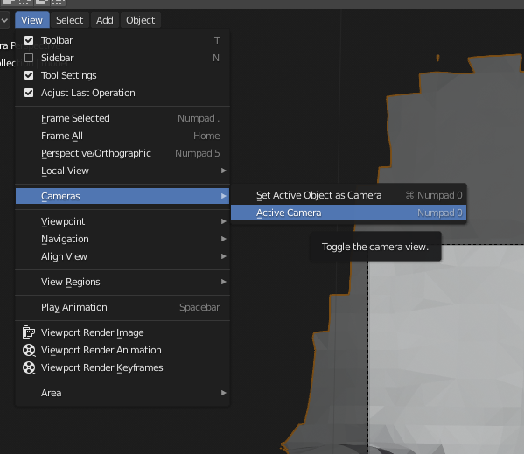

If everything worked smoothly, you should now see a modeled version of your video:

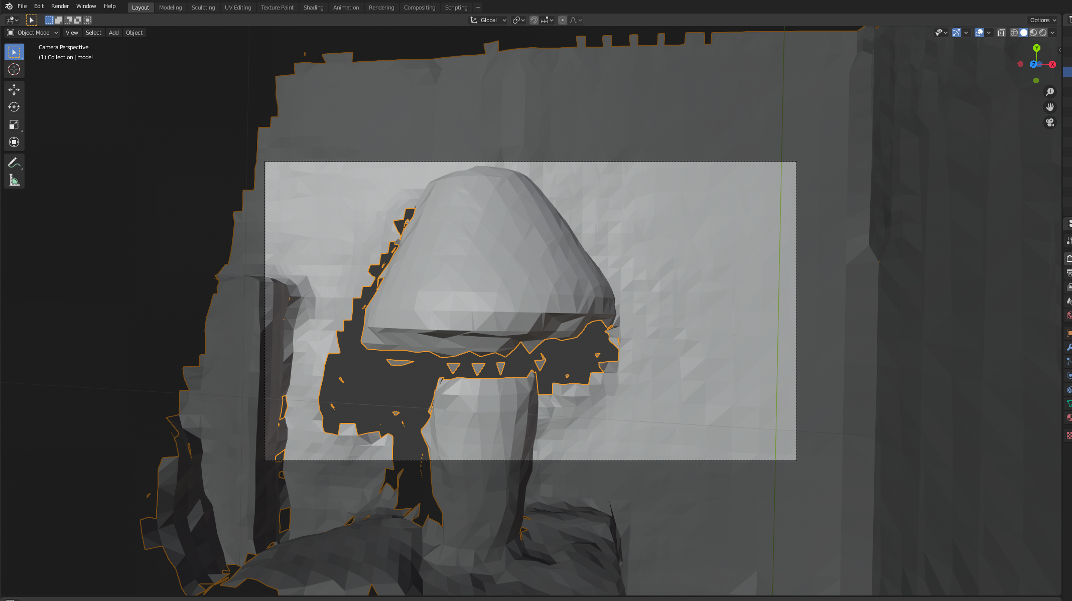

**Step 7:** Now, let’s add the video as background:

Click the camera in the Outliner, and the find its properties. Now check “Background Images” and click “Add Image”. Set the type to “Movie” and locate your mp4 file.

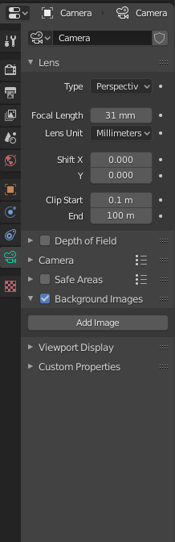

We’re almost done. To get a better view, click your model and, with the mouse over the viewport, press “z” -> Wireframe:

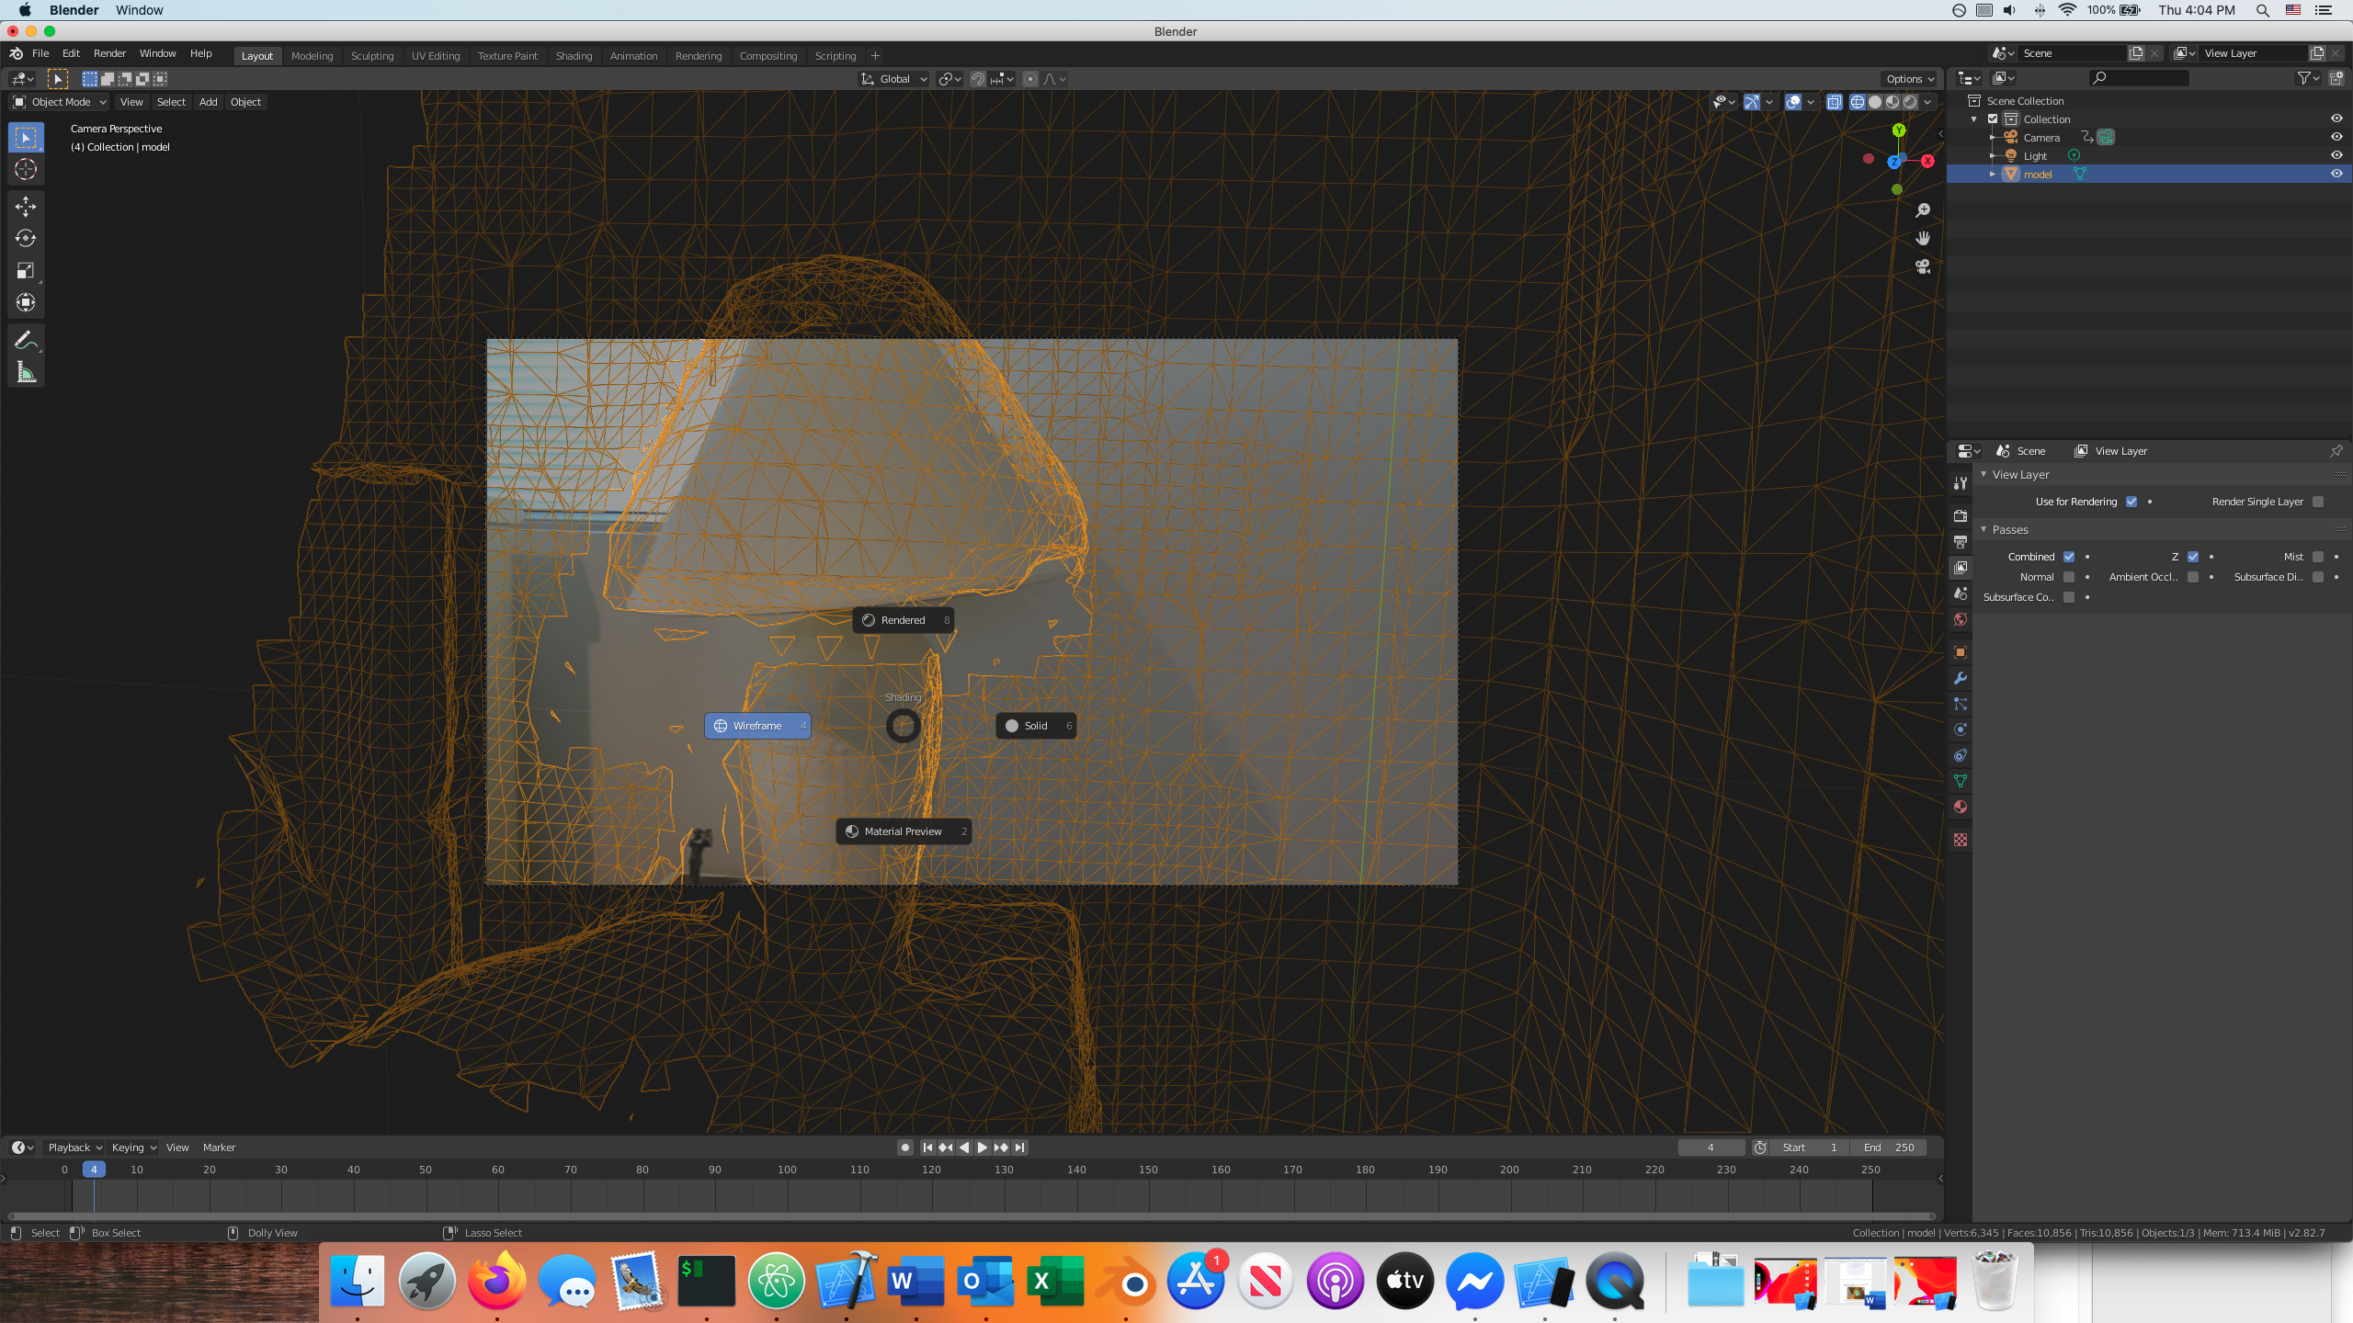

Now, change the bottom view back to timeline, and you should find that the model moves with the video.